1. Genomic Data
Purpose: Identify genetic characteristics of phages and bacteria to analyze their interactions.
Data Types Needed:
- Phage Genomes: Complete genome sequences of bacteriophages.
- Bacterial Genomes: Genome sequences of the bacterial strains targeted by phage therapy.
- Gene Annotations: Detailed information about functional and structural annotations of phage and bacterial genes.
Data Sources:
- NCBI GenBank: A primary repository for complete genome sequences and annotations of phages and bacteria.
- PATRIC: Provides comprehensive bacterial genome sequences and comparative analysis tools.
- European Nucleotide Archive (ENA): Offers access to a wide range of nucleotide sequences.

2. Phenotypic Data
Purpose: Assess how bacterial strains respond to different phages under various environmental conditions.
Data Types Needed:
- Phage Efficacy: Experimental data showing the effectiveness of different phages against various bacterial strains.
- Resistance Profiles: Information about antibiotic resistance or phage resistance patterns in bacterial strains.
- Virulence Factors: Data about bacterial virulence factors that can affect phage-bacteria interactions.
Data Sources:
- Clinical Trials Databases (e.g., ClinicalTrials.gov): Contains information on clinical studies related to phage therapy.
- PubMed and Research Publications: For experimental results on phage efficacy and resistance.
- Bacterial Isolate Collections: Data available through lab collaborations or specialized databases on bacterial isolates.

3. Metadata
Purpose: Incorporate environmental and contextual information that can influence the success of phage therapy.
Data Types Needed:
- Environmental Factors: Temperature, pH levels, oxygen availability, etc., that impact the growth of bacteria and the action of phages.
- Host Data: Host organism data, which may include patient demographics, underlying conditions, and previous antibiotic treatments.
Data Sources:
- NCBI BioProject: Provides metadata linked to genome projects, including sample conditions and experimental details.
- Literature Review: Research articles that detail experimental setups and conditions for phage-bacteria interaction studies.
- European Bioinformatics Institute (EBI): Offers diverse metadata associated with genomic and experimental datasets.

4. Clinical Data
Purpose: Validate the model's predictions with real-world clinical outcomes.
Data Types Needed:
- Patient Case Studies: Clinical records of patients treated with phage therapy, including treatment regimens and outcomes.
- Treatment Success Rates: Data showing the clinical success or failure of specific phage-bacteria combinations.
- Adverse Reactions: Information on any negative outcomes or adverse reactions linked to phage therapy.
Data Sources:
- Hospital Collaborations: Work with healthcare providers or research hospitals that have conducted phage therapy trials.
- Saarland University Medical Center: Check if the medical center or affiliated labs have ongoing clinical research in phage therapy.
- Saarland University's Bioinformatics Department: Potential collaboration with researchers working on clinical data collection.

5. Machine Learning Dataset (for model training and validation)
Purpose: Build and validate your predictive model with a comprehensive dataset.
Data Types Needed:
- Training Dataset: Clean and processed dataset containing features such as genomic data, phenotypic outcomes, and metadata.
- Testing Dataset: A separate set of data reserved for testing and validating the model's predictions.
Data Sources:
- Public Datasets: Utilize public datasets like those on Kaggle related to bioinformatics, genomics, and bacterial resistance prediction.
- Research Collaborations: Work with Saarland University’s researchers and lab groups to gain access to curated datasets.

Support from Saarland University:
- Bioinformatics Department: Saarland University’s bioinformatics department likely has collaborations with microbiologists and clinicians. They may have access to experimental datasets on phage therapy and bacterial resistance profiles.
- Research Groups: Reach out to research groups focused on genomics, machine learning in healthcare, or microbial studies. They could provide additional insights, access to datasets, or advice on model development.
- Saarland University’s Library and Digital Repositories: Utilize the university’s resources for access to paid journals and databases like Springer, Elsevier, and Wiley, which may contain relevant datasets and articles.

Core Data Requirements: Genomic Data, Phenotypic Data, and Metadata
Yes, Genomic Data, Phenotypic Data, and Metadata are crucial for training your model. Let’s break down why each of these is needed:
- Genomic Data:
Purpose: This data contains the complete genome sequences of both phages and bacterial strains. It provides the genetic characteristics that influence how phages interact with bacterial hosts.
Use in Model: You will extract features such as gene sequences, GC content, sequence motifs, and potential resistance genes from the genomic data. This information is essential to identify patterns in phage-bacteria interactions.
- Phenotypic Data:
Purpose: This data includes observable characteristics or traits of bacterial strains and their response to different phages, like growth rates, susceptibility, and resistance profiles.
Use in Model: It is used to link genetic features with real-world outcomes. For example, phenotypic data helps understand how genetic traits in bacteria affect their susceptibility to specific phages.
- Metadata:
Purpose: Metadata refers to contextual and environmental information, such as temperature, pH, and patient data. These factors can influence the effectiveness of phages.
Use in Model: This data allows the model to incorporate external variables that might affect the success of phage therapy, ensuring that the model’s predictions are grounded in real-world conditions.
Together, these three types of data (Genomic, Phenotypic, and Metadata) form the complete dataset that represents the biological interactions your model needs to learn. The model will use this combined dataset to understand which phages are effective against which bacterial strains, given the genetic and environmental contexts.
Gene Annotations:
Bacterial Genomes
- Escherichia coli complete genome
- Staphylococcus aureus complete genome
- Klebsiella pneumoniae complete genome
- Pseudomonas aeruginosa complete genome
- Mycobacterium tuberculosis complete genome

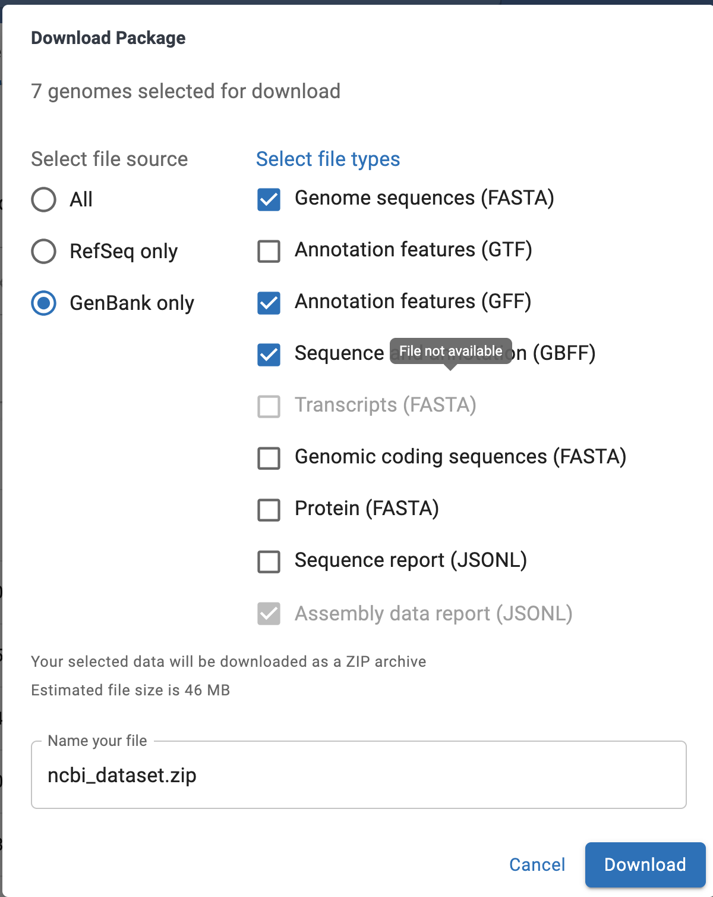
Figure 1: with these features, with 5 genomes

Phages:
Enterobacteria phage T4 complete genome (targets E. coli)
Pseudomonas phage PA1 complete genome (targets P. aeruginosa)
Staphylococcus phage K complete genome (targets S. aureus)
Klebsiella phage KP36 complete genome (targets K. pneumoniae)
Mycobacterium phage D29 complete genome (targets M. tuberculosis)

